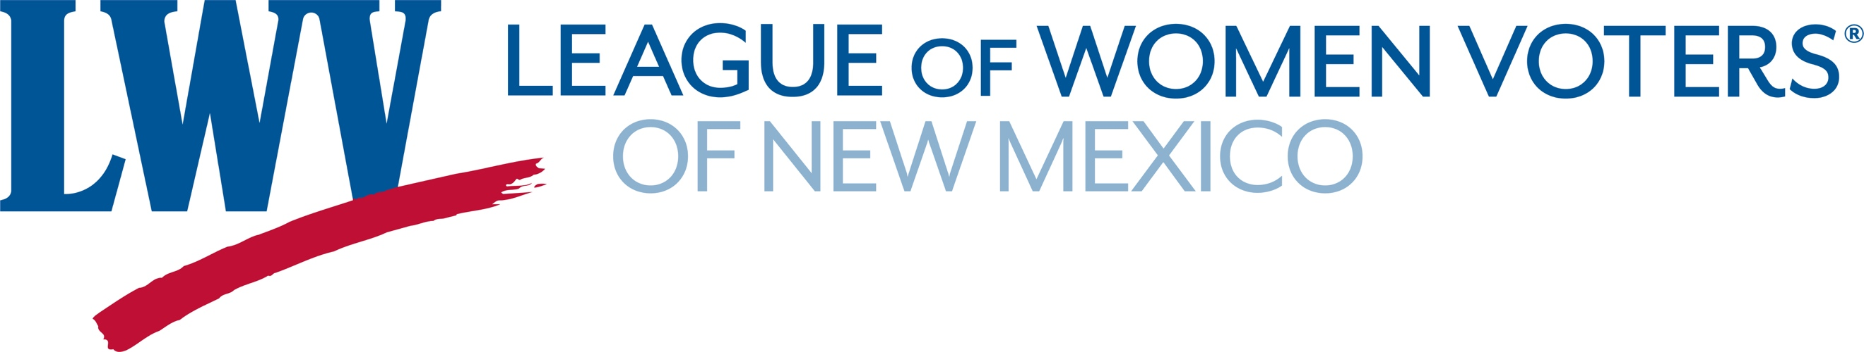

Senator Peter Wirth's "Top 10" Tips for Citizen Advocacy at the
New Mexico Legislature
Presented in true David Letterman style

10. Don't be scared of the Round House – it’s your building.
9. Understand what it takes for a bill to become law.
8. Use the tools on the Legislature's web page: www.nmlegis.gov.
7. E-mail is a great way to communicate with most legislators - but know the legislator's preference
6. A legislator's constituents are generally the best advocates.
5. Be courteous and remember your bill is one of thousands.
4. Bills usually take more than one to legislative session to pass.
3. A great place to meet legislators is on the chamber floor before or after session
2. Speak up at committee meetings.
1. Count your votes and be targeted.
__._,_.___


