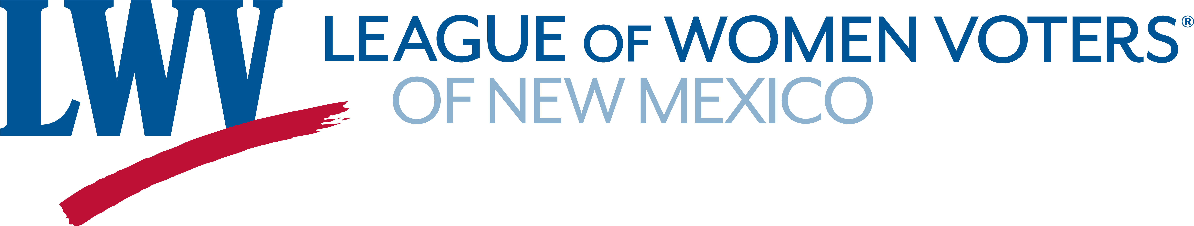
Legislative Priorities for Natural Resources 2022

The League of Women Voters of New Mexico believes that government should promote and ensure responsible stewardship of our natural resources.

LWVNM advocates for policies and incentives that reduce greenhouse gas emissions by promoting greater energy efficiency. The League believes that government should educate the public about how to reduce individual carbon footprints and should offer incentives to do so.

LWVNM advocates for responsible management of our land to preserve habitats and natural landscapes for the continued viability of all species.

LWVNM Supports:

HB 6 Clean Future Act (support with qualifications) Small
The bill requires the state to reduce emissions 50% below 2005 levels by 2030. This would represent a 64% reduction from current levels by 2030. The bill does not allow for offsets to meet the 2030 target. It requires the state to achieve net-zero emissions in 2050 and beyond. Net zero means that any remaining emissions are offset by reductions elsewhere that would not have been achieved otherwise. Offsets cannot exceed 10% of 2005 levels.

SB 14 Clean Fuel Standard Act Stewart
HB 11 Energy Storage Tax Credit Sariñana
HB 14 Bonds and GRT Deduction for Energy Storage Chandler
HB 34 Solar Market Dev’t IncomeTax Credit Extension Ferrary
SB 44 Solar Market Dev’t Income Tax Credit Soules
HB 35 Geothermal Heat Pump Tax Credit Extension Ferrary
SB 68 Geothermal Heat Pump Tax Credits Soules
SB 21 Electric Vehicle Income Tax Credit Tallman
HB 101 NM Reforestation Center Act Sariñana
SB 11 NM Reforestation Center Act Woods
HB 125 Sustainable Building Tax Credit Ortez
HB 37 Community Energy Efficiency Dev’t Block Grant Act Ortez

LWVNM opposes:

HB 4 Hydrogen Hub Act Lundstrom
The bill offers subsidies to produce hydrogen using fossil fuels through a process that is accompanied by methane emissions and that depends on the unproven technology of carbon dioxide sequestration. The negative impact on the state budget is unknown but significant.

Contact Information:
Barbara Calef (505) 662-3825 bfcalef@gmail.com
Judy Williams (505) 920-7817 jkwilliams24@gmail.com
Jeanne Logsdon (505) jlogsdon@unm.edu

