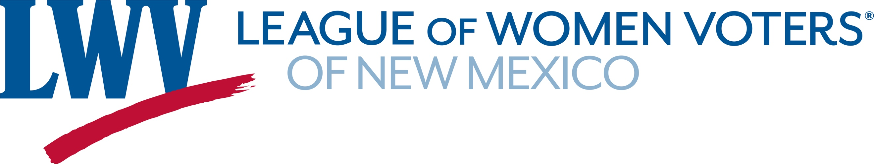

Legislative Priorities for Voting 2022

The League advocates for

- Methods that increase voter participation, including automatic voter registration and same-day voter registration;

- Systems that improve the election experience and provide ease of ballot access including vote-by-mail, supplemented by secure ballot drop boxes and accessible voting centers;

- An all-inclusive system of voting that allows all registered voters to participate in the primary election, so that
  - voters who are not enrolled in a major political party may vote on one ballot per primary without having to enroll in that particular party, and
  - voters enrolled in a major political party can vote only on the ballot of their party.

LWVNM supports:

SB 8 NM Voting Rights Act Sen. Wirth
Strengthens voting rights and protections, makes it easier to register and vote, and reinstates some of the expired voting provisions enacted in the 2020 Special Session.

SB 6 Elections Fix Bill Sen. Ivey-Soto
Part of a continuing effort to consolidate and clarify voting laws and administrative processes and strengthen election security.

HJR 5 Open Primaries CA Sen. Dixon

SJR 4 Open Primaries CA Rep. Tallman

SJR 5 Run Off Elections CA Rep. Pope

SB 144 Intimidation of Election Workers Sen. Duhigg

Contact: Renny Ashleman (702) 324-6905 ashlemanr@gmail.com

