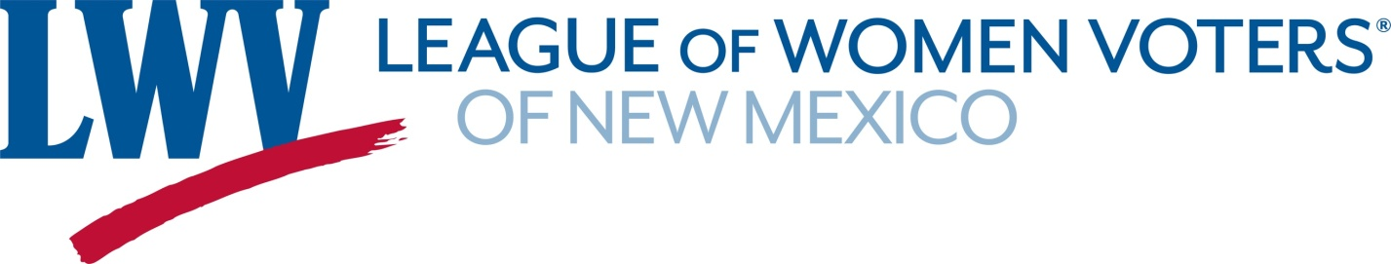
Legislative Priorities for the 2022 Legislative session

Expansion of Voting Rights and Improved Election Administration

The League advocates for

- Methods that increase voter participation, including automatic voter registration and same-day voter registration
- Systems that improve the election experience and provide ease of ballot access including vote-by-mail, supplemented by secure ballot drop boxes and accessible voting centers
SB 8 NM Voting Rights Act Sen. Wirth
Strengthens voting rights and protections, makes it easier to register and vote, and reinstates some of the expired voting provisions enacted in the 2020 Special Session.

SB 6 Elections Fix Bill Sen. Ivey-Soto
Part of a continuing effort to consolidate and clarify voting laws and administrative processes and strengthen election security.

Legislation that will deal with climate change

LWVNM advocates for policies and incentives that reduce greenhouse gas emissions.

HB 6 Clean Future Act (support with qualifications) Rep. Small
The bill requires the state to reduce emissions 50% below 2005 levels by 2030. This would represent a 64% reduction from current levels by 2030. The bill does not allow for offsets to meet the 2030 target. It requires the state to achieve net-zero emissions in 2050 and beyond. Net zero means that any remaining emissions are offset by reductions elsewhere that would not have been achieved otherwise. Offsets cannot exceed 10% of 2005 levels.

Independent Redistricting Commission
The League of Women Voters of New Mexico believes that responsibility for redistricting should be vested in an independent redistricting commission with membership that reflects the diversity of the population. We support:

HJR9 Independent Redistricting Commission Reps. Figueroa & Ely
This is a proposed constitutional amendment, If approved by the Legislature the question creating an independent redistricting commission will go on the 2022 general election ballot.

Contact: Dick Mason 505-239-3804 leaders@lwvnm.org

