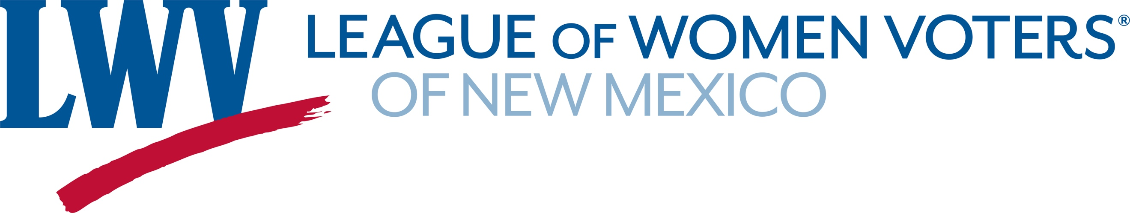
Legislative Priority – Redistricting Reform 2022
The League of Women Voters of New Mexico believes that responsibility for redistricting should be vested in an independent redistricting commission with membership that reflects the diversity of the population.

LWVNM supports a redistricting process and standards that provide the people with a meaningful choice in electing their representatives and facilitate holding government accountable.
LWVNM supports:
HJR9 Independent Redistricting Commission Representatives Figueroa & Ely
What would HJR9 do? If approved by the Legislature it would put the question of creating an Independent Redistricting Commission on the 2022 general election ballot.
Why we need it: The 2021 Citizen Redistricting Committee (CRC) showed the value of a semi-independent redistricting entity. In a short time frame, the seven member CRC conducted more than 14 public meetings around New Mexico and provided three sets of recommendations for each set of district maps to be considered by the legislature. The CRC did an admirable job in a very compact period of time.
The CRC proposed maps were only recommendations. That means the legislators did not have to choose one of the CRC maps, but could create their own. Thus they were able to choose their constituents rather than having constituents choose their legislators. The Legislature should approve HJR 9 and provide voters the opportunity to vote for an independent redistricting commission.
A 2020 poll by the UNM Center for Social Policy supports passage of HJR9. According to the survey results, the public wants new redistricting laws. Ninety-three percent of respondents believe it is important for New Mexico to consider implementing an independent redistricting commission
SM 15 Study County Redistricting Senator Brenda McKenna
Requests that the University of New Mexico convene a task force to study how to standardize the way counties conduct redistricting. There are no state laws regulating county redistricting.

Contact: Dick Mason 505-239-3804 act@lwvnm.org

