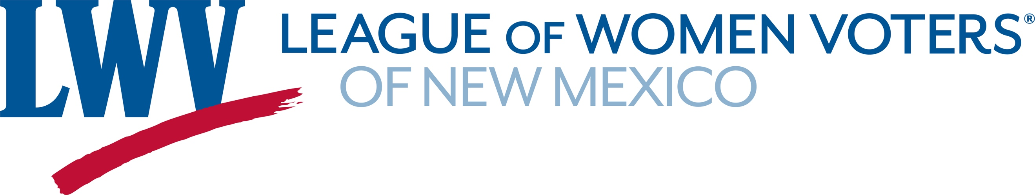
Legislative Priorities for Fairness, Finance, and Taxes 2022

LWVNM believes that the tax system should be progressive and equitable, taking into consideration relevant differences in annual income. The tax system should generate adequate revenue to meet essential needs. Also, LWVNM believes that the Legislature should consider new progressive revenue generators. Although regressive, the LWVNM may support “sin taxes” if they achieve a socially desirable goal.
In the 2022 session the LWVNM will be opposing attempts to give tax breaks that will decrease the revenues needed to fund essential services. This is an election year and the state is flush with additional revenues from the federal government and revenues from the oil & gas boom. The temptation for some policymakers is to use some of those revenues to give tax relief. New Mexico has been here before, giving tax cuts during flush times and then cutting services in hard times. Legislators have promised comprehensive tax reform in the 2023 sixty-day session.

LWVNM opposes:
SB5 Reduction in the Gross Receipts Tax Senator Bobby Gonzales
This reduction would cost the General Fund $200 million and does not propose any
revenue to replace it.
HB48 Eliminate the Personal Income Tax on Social Security Rep. Brown
HB49 Eliminate the Personal Income Tax on Social Security Rep. G. Armstrong
SB49 Eliminate the Personal Income Tax on Social Security Senator Tallman
Studies have shown that most of the benefits of this would go to higher income seniors.
Many lower income seniors do not pay taxes. These proposals would also remove funds from the general fund without any provisions to replace them.
HB76 Military Retirement Income Tax Exemption Rep. Anderson
SB85 Military Retirement Income Tax Exemption Senator Pope
These proposals would remove funds from the general funds without any plans to replace them.
Although these only exempt the first $30,000 of the benefit there is no means testing.

LWVNM will be supporting other legislation that raises revenue from those who can most afford it. We will also be supporting taxes on alcohol and tobacco products.

Contact Information: Richard Mason (505) 239-3804 act@lwvnm.org

