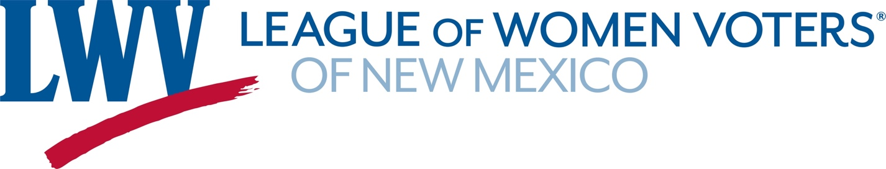

Legislative Priorities for Education 2022

LWVNM believes that every student should have access to a high- quality, equitable public education regardless of race, ethnicity, ability, family income, or location. The League believes in accountability, transparency, and equity in the use of public funds for education.

LWVNM advocates for
- funding adequately and advancing policies for a high-quality, equitable, culturally and linguistically relevant education system, early childhood through higher education;
- allocating sufficient resources through the State Equalization Guarantee funding formula to meet the educational needs of economically disadvantaged children, English language learners, Native American students, and students with disabilities and Yazzie-Martinez court orders;
- compensating teachers, health and social service professionals, and other educators with more competitive salaries;
- strengthening teacher education programs and professional development opportunities;
- funding scholarships so that more students complete college and professional degrees;
- providing more funding to improve remote, hybrid, and in-person instruction and infrastructure;
- addressing teacher shortages through teacher pipeline scholarships, incentives, loans, internships, mentoring, and residencies with a focus on recruiting and retaining an educational workforce that reflects the diversity of the state’s student population.

LWVNM Supports:

SB1 Increasing Salary for Licensed Teachers Stewart, Hemphill
SB 32 Outdoor Learning Program Funding Hemphill
SB 140 Opportunity Scholarship Act Stefanics, Garrett
HB 13 Teacher Residency Changes Sariñana, Soules
HB 130 Personal Finance as Elective Maestas, Madrid
SB 177 Personal Finance for Graduation Pinto, Kernan

For more information, contact LWVNM Education Co-Chairs,
Meredith Machen and Eileen VanWie at educ@lwvnm.org or 505 577-6337. https://lwvnm.org/

