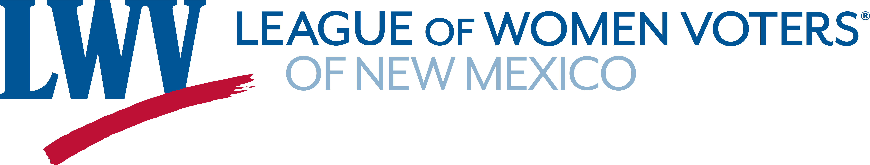

Legislative Priorities for Setting Salaries for Elected Officials, 2022

The League of Women Voters of New Mexico supports legislative compensation that is fair and reasonable, recognizing that there is a cost to government and that the cost should be paid by the taxpayers of New Mexico.
The League recommends:
- paying a salary that is high enough to attract and retain qualified, committed legislators;
- providing legislators with adequate legal research and office assistance;
- requiring legislative procedures and schedules to promote efficiency, transparency, accountability, and public accessibility.

LWVNM Supports:

SJR 8 Salaries for Public Officials, CA Sens. Ivey-Soto, Gonzales, Duhigg
HJR 10 Public Officer Salary Commission Reps. Rubio, Martinez, Ely

HM 26 Study Legislative Sessions and Salaries Reps. Rubio, Garratt, Sariñana, Herrera, Ortez

Contact Information:
Judy Williams (505) 920-7817 jkwilliams24@gmail.com

