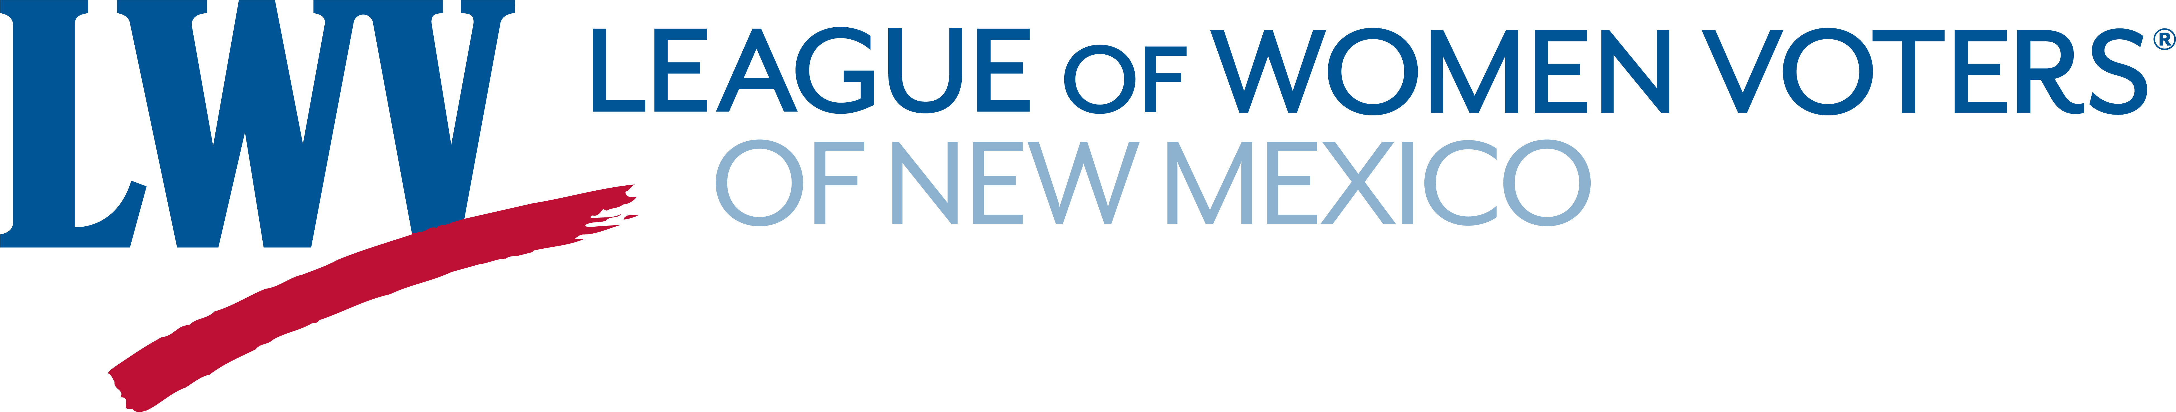
Legislative Priorities for Environment 2024

The League believes that the state, water regions, and local governments must preserve and restore rivers and watersheds.
LWVNM supports:
SB 1 Water Trust Fund Sen. Wirth

The League supports policies and incentives that reduce greenhouse gas emissions by promoting greater energy efficiency and by developing clean, renewable energy sources.

LWVNM supports:

HB 41 Clean Transportation Fuels Reps. Ortez and Chandler

HB 91/SB 59 Geothermal Resource Project Fund Rep. Roybal Caballero, Sen. Ortiz y Pino

HB 133 Local Solar Energy Fund Reps. Szepanski, Roybal Caballero

LWVNM supports rigorous regulation and enforcement to prevent mining and drilling activities from contaminating surface or ground water or the surrounding landscape

LWVNM supports:

HB 133 Oil and Gas Act Changes Rep. Ortez

The League supports the conservation and protection of wildlife and their habitats for the contribution they make toward the health and sustainability of the environment.

LWVNM supports:
HB 23 State Game Commission Changes Rep. McQueen

The League of Women Voters of New Mexico believes that government should promote and ensure responsible stewardship of our natural, human, and cultural resources, particularly in the face of growth and development.

LWVNM supports:
SB 9 Conservation Legacy Permanent Fund Sens. Neville, Wirth

The Conservation Legacy Permanent Fund directs funding to conserve forests, manage noxious weeds, improve soil and water health, improve river habitats and surface water quality, develop outdoor recreation infrastructure, conserve outdoor cultural heritage, and fund outdoor equity programs.

Contact Information:
Barbara Calef (505) 205-5705 bfcalef@gmail.com
Jeanne Logsdon (505) 710-3886 jlogsdon@unm.edu

