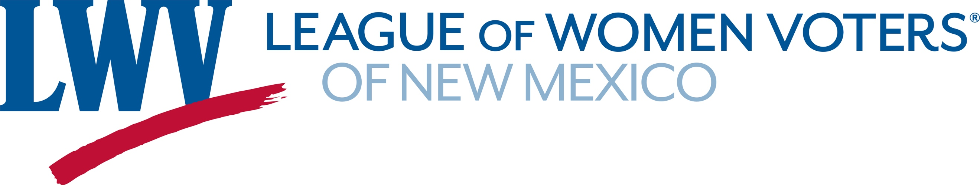

Legislative Priorities for Voting & Elections & Ethics 2024

The League advocates for

- methods that increase voter participation, including automatic voter registration and same-day voter registration;
- systems that improve the election experience and provide ease of ballot access, including vote-by-mail supplemented by secure ballot drop boxes and accessible voting centers;
- an all-inclusive system of voting that allows all registered voters to participate in the primary election so that
  - voters who are not enrolled in a major political party may vote on one ballot per primary without having to enroll in that particular party, and
  - voters enrolled in a major political party can vote only on the ballot of their party.
The League believes in strong ethics rules and financial reporting requirements, ensuring maximum transparency in government at all levels.

In 2023 the League supports:

HB4 Voting Rights Protections Rep. Javier Martinez
Includes:
- automatic voter registration; permanent request for absentee ballots;
- clarification of the restoration of felon voting rights;
- the Native American Voting Rights Act;
- limits access to voting data to protect voter privacy.

HB54 Ballot Requests for Open Primary Election Rep. Natalie Figueroa
SB73 Primary Elections Voting Requirements Sen. Bill O’Neill
Both bills allow Declined to State (DTS) and those registered with minor parties to select the ballot of a major party without changing their voter registration designation. The bills do not allow those registered in a major party to select the ballot of another major party.

SB43 Intimidation of Election Workers Sen. Katy Duhigg
Protects election administrators and workers from intimidation. This assures that voters will have safe and secure access to voting.

SB180 Elections Changes Sen. Katy Duhigg
Part of a continuing effort to consolidate and clarify voting laws and administrative processes and strengthen election security.

Contact: Dick Mason 505-239-3804 act@lwvnm.org

