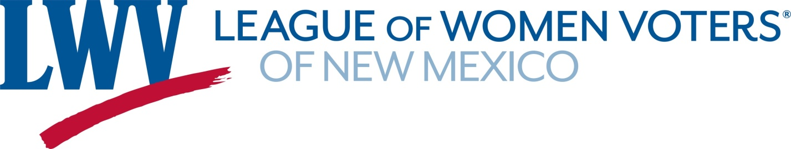
Legislative Priorities for the 2025 Legislative Session

SJR1 Salary Commission – Constitutional Amendment Senators Figueroa & Wirth
If passed by the Legislature, the resolution would go on the 2026 ballot. If passed by the voters, it will create an Citizen Salary Commission that would determine salaries for the Legislature.
SB218 Election Changes Senator Duhigg
This bill includes updates to our election codes to address issues that have arisen in past elections.
In addition, it moves all remaining nonpartisan local elections to November of odd number years.

HB186 State Administered Health Coverage Plan Representative Szczepanski
This would allow individuals that do not meet the Federal qualifications for Medicaid to buy into the state Medicaid program on a sliding scale.
SB46 Interstate Medical Licensure Act Senator Trujillo
This would have New Mexico join the Interstate Medical Licensure Compact, which facilitates doctors licensed in other states to become licensed in states that are members of the Compact. This is just one of the interstate licensing compacts the League will be supporting.

SB145 Housing Trust Fund Senator Gonzales
Makes an appropriation ($500M) to the Housing Trust Fund with a 10% set aside for Local Municipalities and Counties.
SB205 State Office of Housing Planning & Production Senator Gonzales
Creates a State Office of Housing Planning and Production providing powers & duties

SB21, 22 Water Quality and Pollution Senator Wirth
SB 21 establishes state authority to take over permitting for those waters still federally protected.
SB 22 establishes state authority for the permitting of waters no longer federally protected.

SB4 Clean Horizons and Greenhouse Gas Emissions Senator Stewart
This bill would establish statewide greenhouse gas (GHG) emissions limits and reporting requirements.

SB23 Increase Gas and Oil Royalties Senator Muñoz
Increases the maximum royalty rate paid for oil or gas removed from state trust lands.

Contact: Hannah Burling 505-603-1601 act@lwvnm.org
Dick Mason 505-239-3804 act@lwvnm.org

