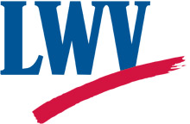
League of Women Voters of New Mexico

Publicizing Non-League Events Policy
(Adopted September 11, 2021)

The LWVNM may publicize the events of other organizations, as long as

- there is no encouragement to donate;
- the goal of the event is to educate the public, to give input, and/or to hold decision makers accountable;
- the events are strictly limited to advocacy on issues that the League supports and/or education of the public;
- the organization is strictly nonpartisan; and
- the decision is approved by the Executive Committee of the Board of LWVNM.

