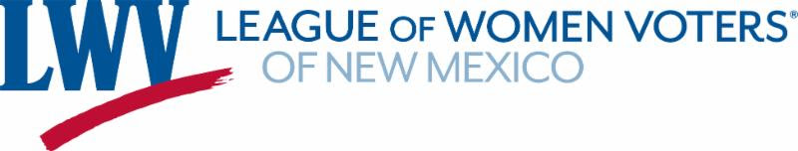

2026 Advocate Travel & Activity Reimbursement Form
This form is used to request reimbursement for approved advocacy-related travel expenses and to document legislative contacts made in connection with League advocacy. Completion of the advocacy reporting sections is required for reimbursement.

Advocate Information
Name
Email
Phone
Address for check

Reimbursement Request
Expense Type | Description / Location | Amount ($)
Mileage
Lodging
Other (specify)

Total Amount Requested: $ ____________________

Legislative Advocacy Report
Please complete the following for each legislator or legislative office you contacted. Attach additional pages if needed.
Legislator Name | Issues, bill numbers discussed | Handout  Left? | Ask  Made? | Legislator  Response, positive, negative, neutral?
(Over)

Key takeaways, follow-up needed, or observations (Legislators’ responses are vital for the League to craft strategy and messaging.):

Did you attend any committee hearings? If so, do you have any takeaways?

Certification
I certify that the expenses listed above were incurred in connection with approved League of Women Voters of New Mexico advocacy activities and that the information provided in this form is accurate.
Signature: ________________________________ Date: ________________
Please return to:
LWVNM
6739 Academy Rd. NE Suite 124
Albuquerque, NM 87109-3352

